**P250/1**

**GEOGRAPHY**

**Paper 1**

**July - August**

**3 Hours**



**ELITE EXAMINATION BUREAU MOCK 2019**

**Uganda Advanced Certificate of Education**

**GEOGRAPHY**

**(PHYSICAL GEOGRAPHY)**

**Paper 1**

3Hours

**INSTRUCTIONS TO CANDIDATES:**

* *This paper consists of* ***three*** *sections,* ***A, B*** *and* ***C***
* *Answer* ***four*** *questions in all.*
* *Section A is compulsory*
* *Answer* ***ONE*** *question from section* ***B*** *and* ***ONE*** *from section* ***C****.*
* *Any additional question(s) attempted will* ***NOT*** *be marked.*
* *Credit will be given for use of sketch maps, diagrams and specific examples studied in the field.*

**Turn Over**

**SECTION A**

**Questions 1 and 2 are compulsory**

1. Study the 1:50000 (UGANDA) NAAM OKORA map extract part of sheet 16/2, series Y732, Edition 1-U.S.D and answer the questions that follow.

a)(i) State the relief feature at grid reference 388641. (1mark)

(ii) State the grid reference of the culvert on river Wangali. (1mark)

b) Calculate;

(i) Area covered by paimol country. (2marks)

(ii) height of the hill N. west of Lapana. (2mark)

c) Draw a relief section of the area along Easting 28 between 280640 and 280730, on it mark and name

- two relief features,

- two communication lines

- one vegetation type. (9marks)

d) Describe the;

i) Characteristics of river pager. (4marks)

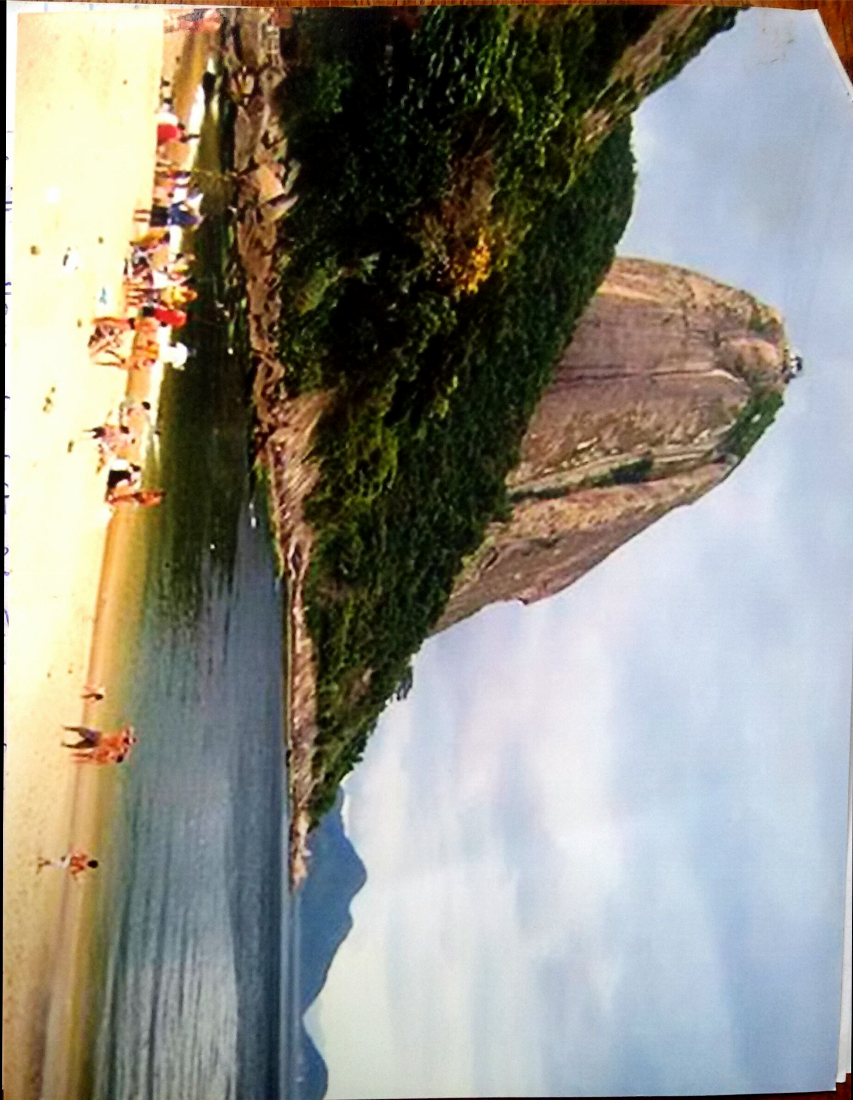 (ii) relationship between drainage and communication shown on the map extract. (6marks)

**COMPULSORY PHOTOGRAPHIC INTERPRETATION QUESTION.**

2. Study the photograph provided below and answer the questions that follow.

(a) Draw a land scape sketch of the area shown on the photograph, on it mark and name;

- drainage features

- beach,

- Saddle/col

- Plug dome,

- bay (9marks)

b) Account for the formation of the following

(i) bay (5marks)

(ii) plug dome (6marks)

c) Describe the relief shown on the photograph (3marks)

d) Giving reasons for your answer, suggest an area in E. Africa where this photograph could have been taken. (2marks)

**SECTION B**

**(Choose one question from this section)**

3. a) Distinguish between intrusive and extrusive vulcanicity (6marks)

b) Account for the formation of volcanoes in E. Africa. (19marks)

4. Account for the formation of lakes in E. Africa. (25marks)

5. Describe the formation of the following

a) stump

b) wave cut platform

c) Geo (25marks)

**SECTION C**

**(Choose ONE question from this section)**

6. Account for humidity variations in E. Africa. (25marks)

7. Examine the influence of altitude in the distribution of natural vegetation in E. Africa. (25marks)

8. To what extent has relief influenced soil profile development in East Africa? (25marks)

**END**